CSA1509-Cloud computing and Big Data Analytics
Name : yuvan shankar L
Reg.no: 192511072

EXP17- Change Hardware compatibility of a VM (Either by clone/create new one) which is already created and configured and run simple unix commands
Aim:
Change Hardware compatibility of a VM (Either by clone/create new one) which is already created and configured and run simple unix

Steps:
- Download VMware software and install it as Type-2 Hypervisor.
- Download Ubuntu or tiny OS as ISO image file.
- In VMware workstation → Create new VM
- Do the configuration based on given conditions.
- Create VM
- Go to VM→ Manage→Clone.
- A Orange color desktop will open, simple unix commands are performed.
- Launch the VM.

Implementation:
- Download and open VMware software.

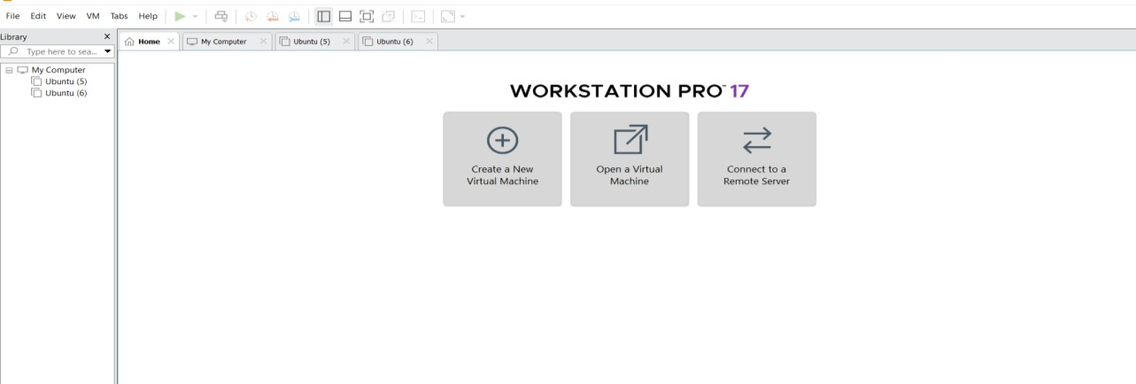

Create a new VM

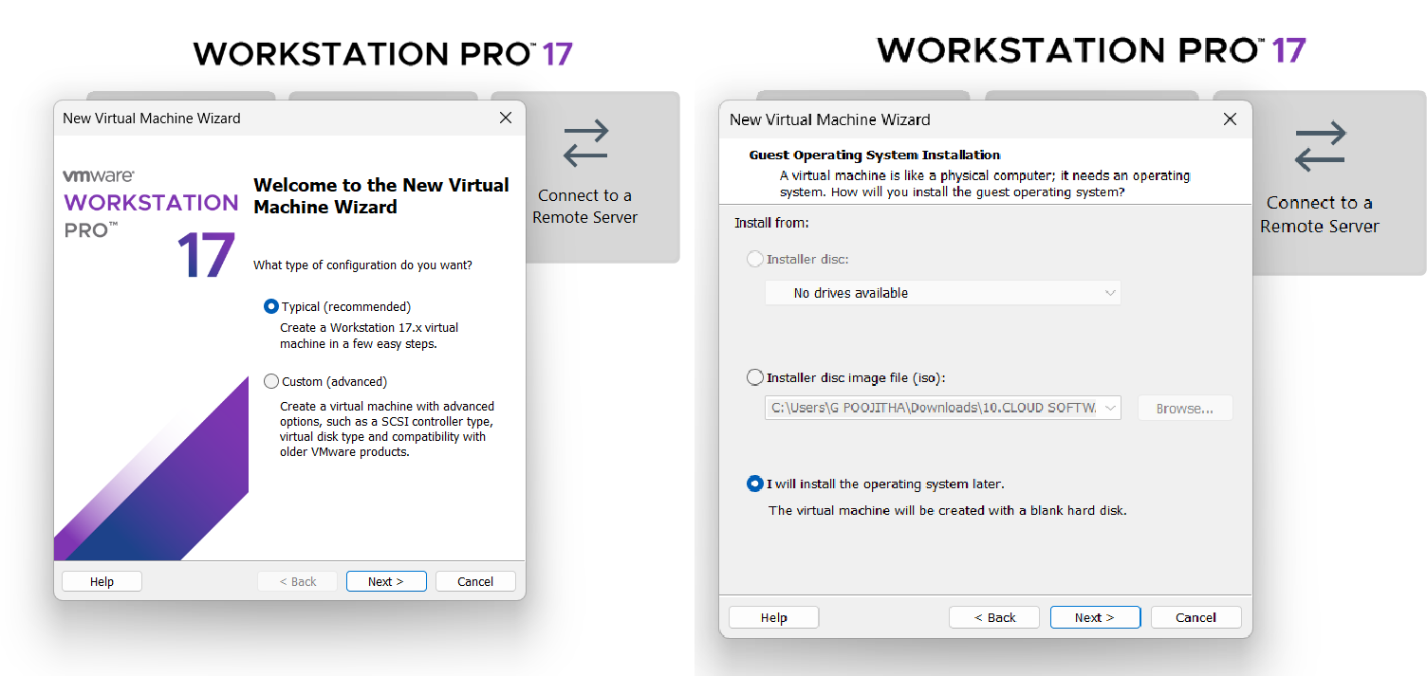
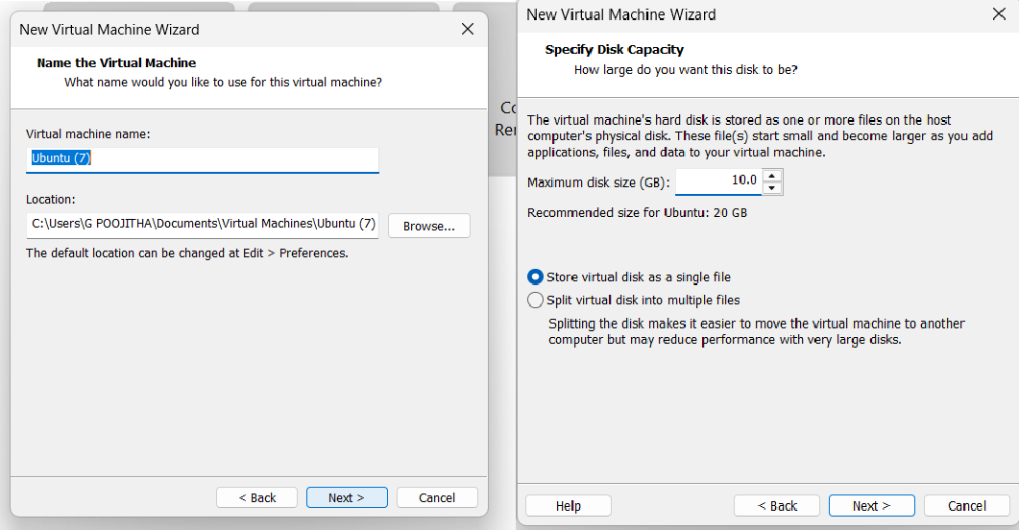

Fig : Name it anything→click on next→Adjust the size of disk → change the option to first and then click on next.

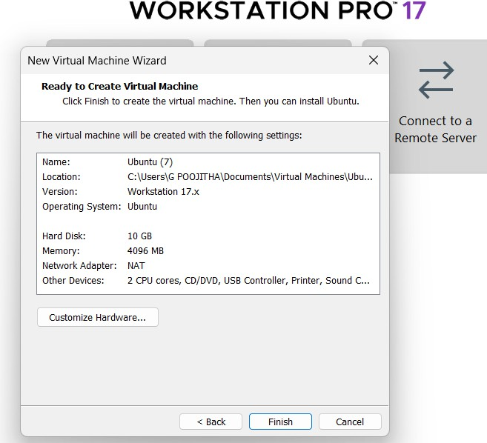Fig: Click on Finish to Launch .

VM is created
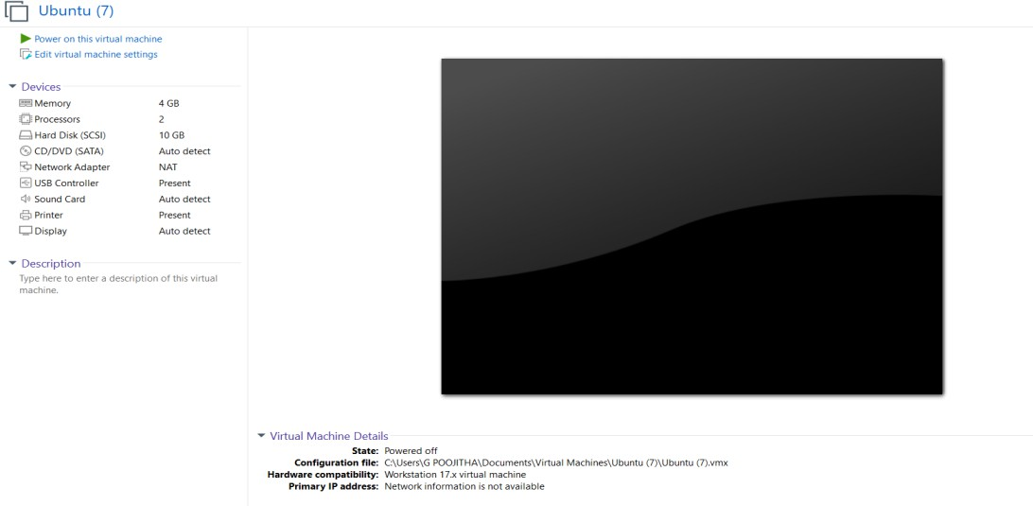
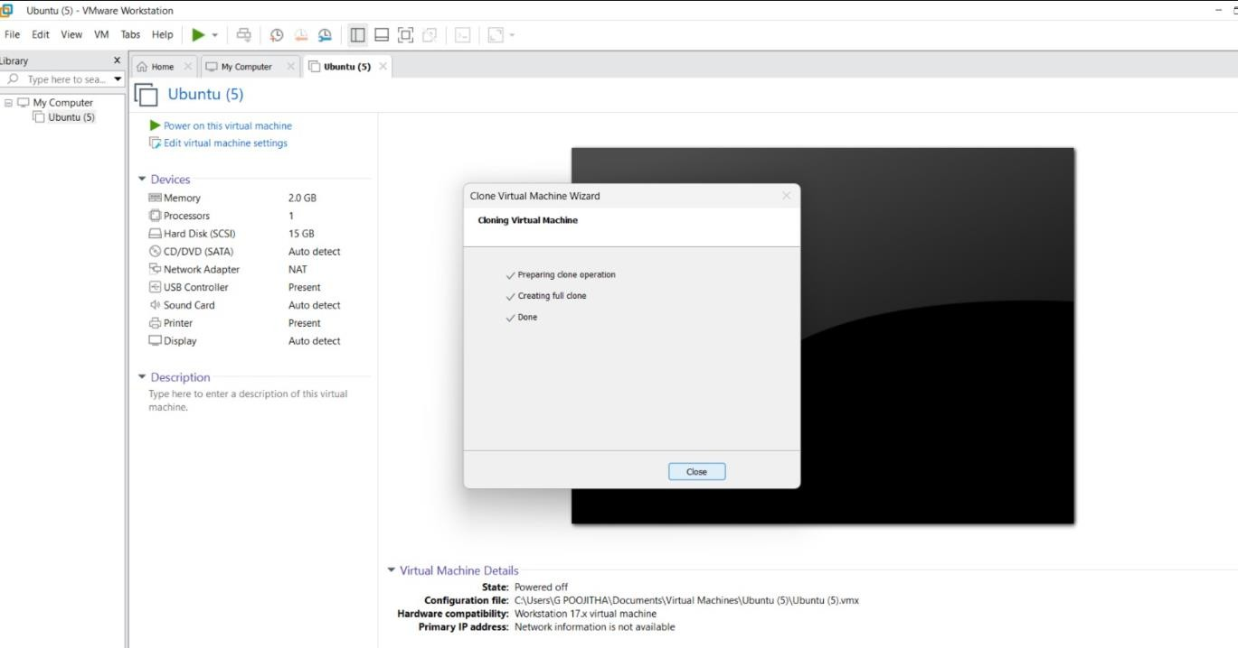

Create Clone
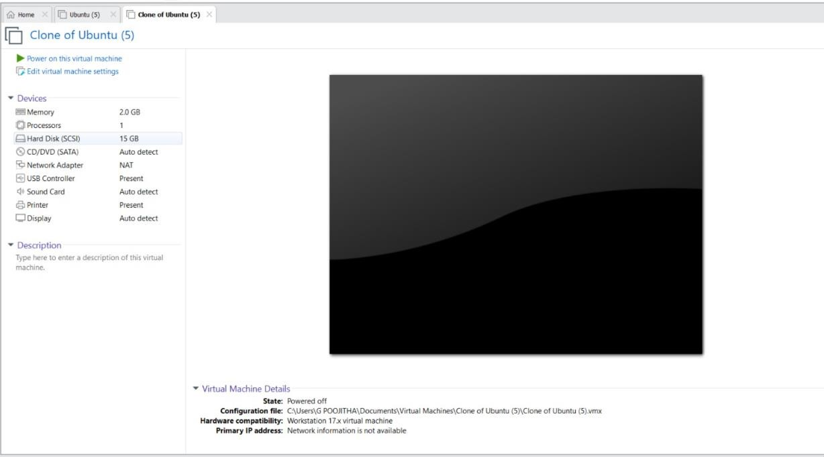
Fig : SSClone has Created and it has same properties as before VM.

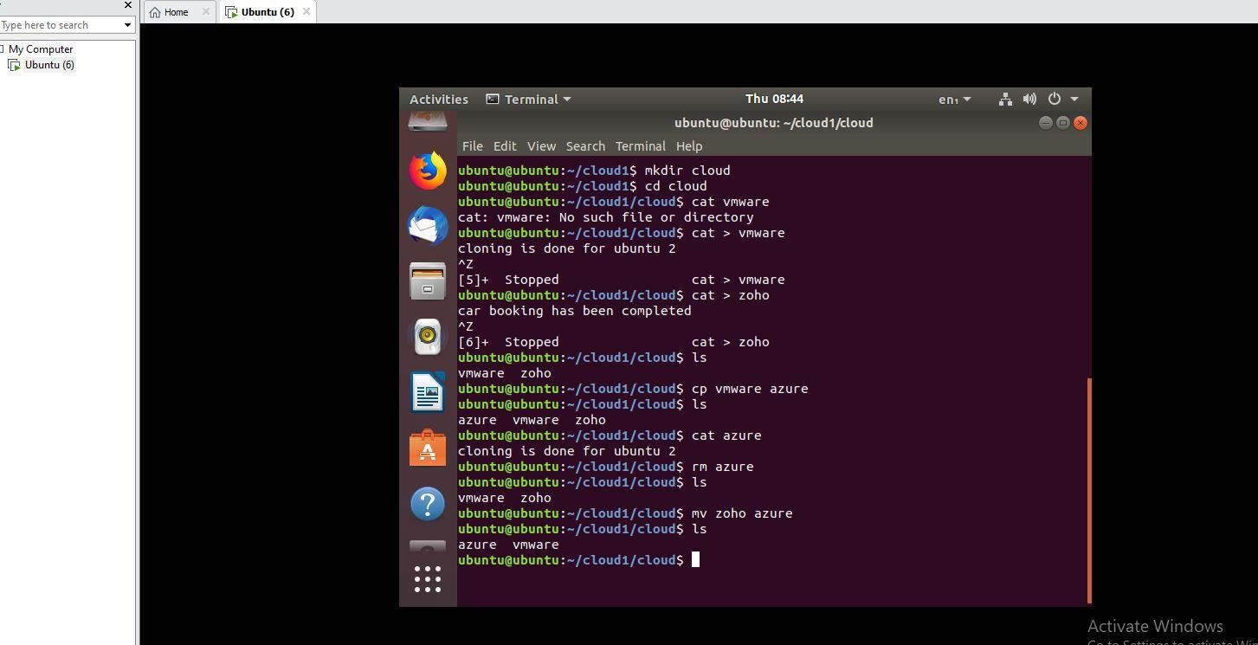
Fig : unix commands are performed

